DRAFT - ICT Project Guidance

Documentation: Diagrams

Version:

0.1

Author:

Sky Sigal, Solution Architect

## Description

<TODO>

## Synopsis

<TODO>

## Contents

Description 1

Synopsis 1

Contents 2

Synopsis 3

Introduction 3

Heading Level 3 3

Heading Level 4 3

Appendices 4

Appendix A - Document Information 4

Images 4

Tables 4

References 4

Review Distribution 4

Audience 4

Structure 4

Diagrams 4

Terms 5

## Introduction

BOSSCARD/ RAID: Background [], Objective, Options, Scope[In/Out], Stakeholders [Users], Constraints, Assumptions, Risks, Dependencies, Decisions, Deliverables.

Enterprise Architecture

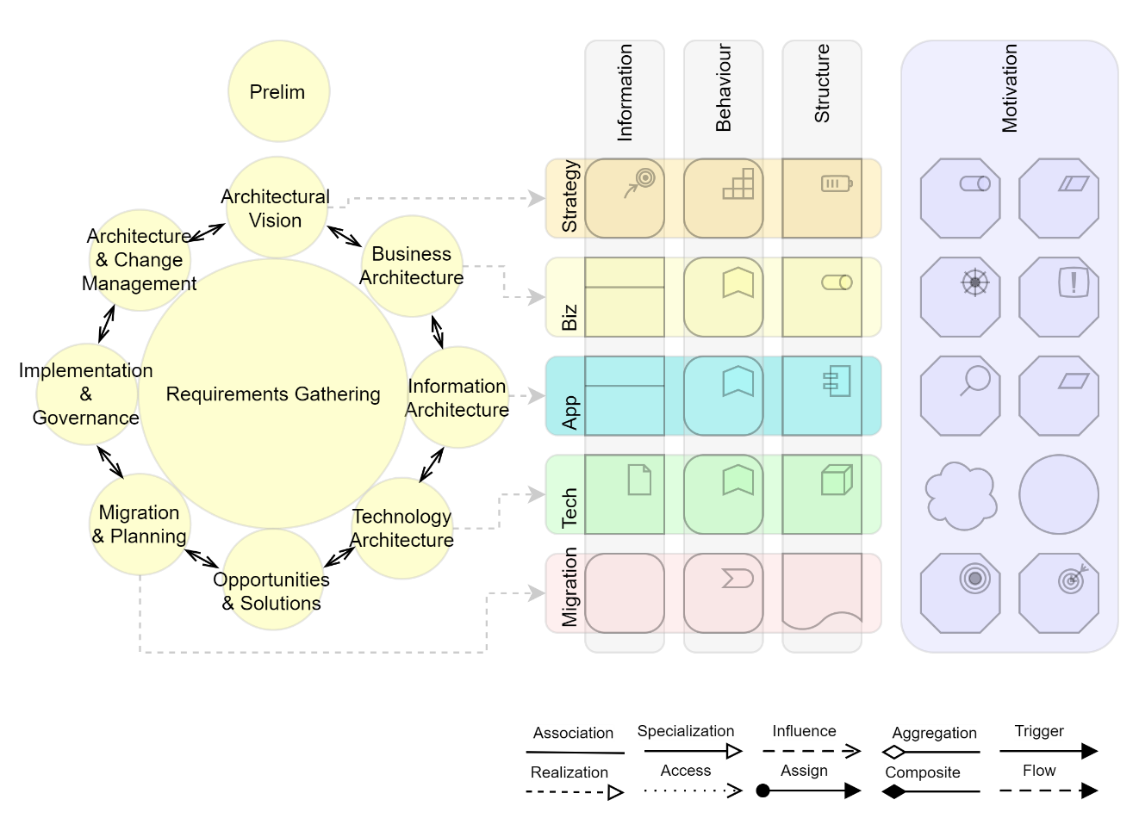

Entity Relationship Diagrams (ERD)

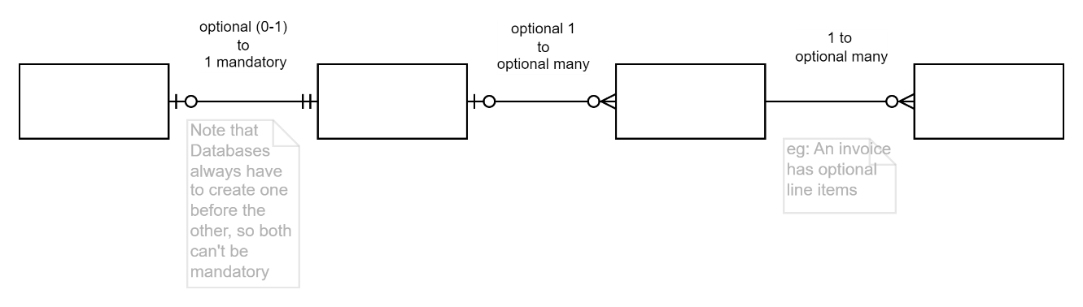

Component Diagrams

Class Diagrams

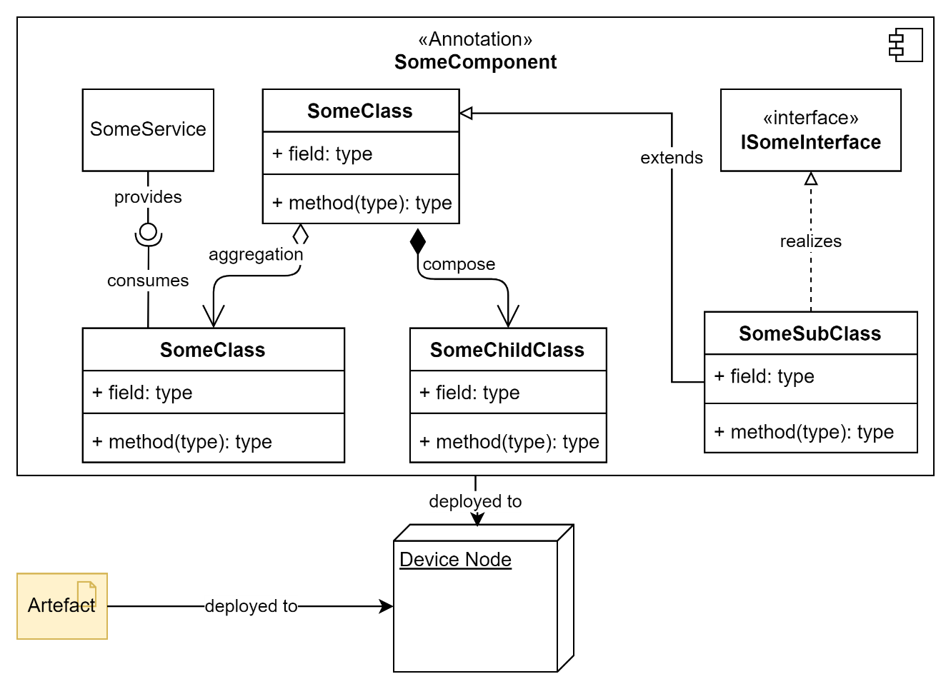

Appendices

Appendix A - Document Information

### Versions

0.1 Initial Draft

### Images

Figure 1: TODO Image 2

### Tables

Table 1: TODO Table 3

Table 2: TODO Table 2 3

### References

**There are no sources in the current document.**

### Review Distribution

The document was distributed for review as below:

|  |  |
| --- | --- |
| Identity | Notes |
| Sandy Britain, Enterprise Architect |  |
| Amy Orr, Data Domain Architect |  |
|  |  |

### Audience

The document is technical in nature, but parts are expected to be read and/or validated by a non-technical audience.

### Structure

Where possible, the document structure is guided by either ISO-* standards or best practice.

### Diagrams

Diagrams are developed for a wide audience. Unless specifically for a technical audience, where the use of industry standard diagram types (ArchiMate, UML, C4), is appropriate, diagrams are developed as simple “box & line” monochrome diagrams.

### Terms

Refer to the project’s Glossary.

##### IT

: acronym for Information, using Technology to automate and facilitate its management.

##### ICT

: acronym for Information & Communication Technology, the domain of defining Information elements and using technology to automate their communication between entities. IT is a subset of ICT.